**Application LifeCycle MgMt**

## **Rolling Updates && Rollbacks**

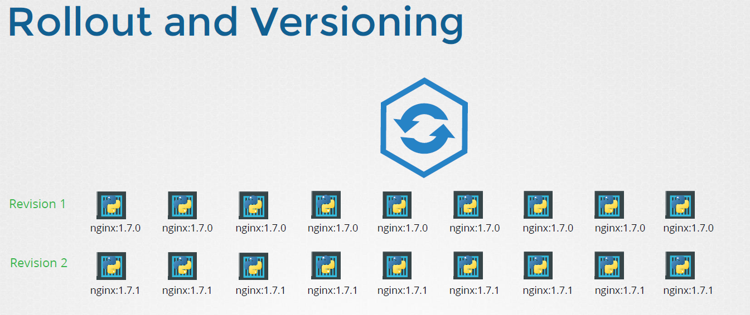

When you 1st create the deployment, it triggers a rollout , a new rollout creates a new deployment revision, let call it Revision One.

In the future when the application is upgraded, meaning when the container version is updated to new one, a new rollout is triggered and a new deployment version is careated named Revsion 2

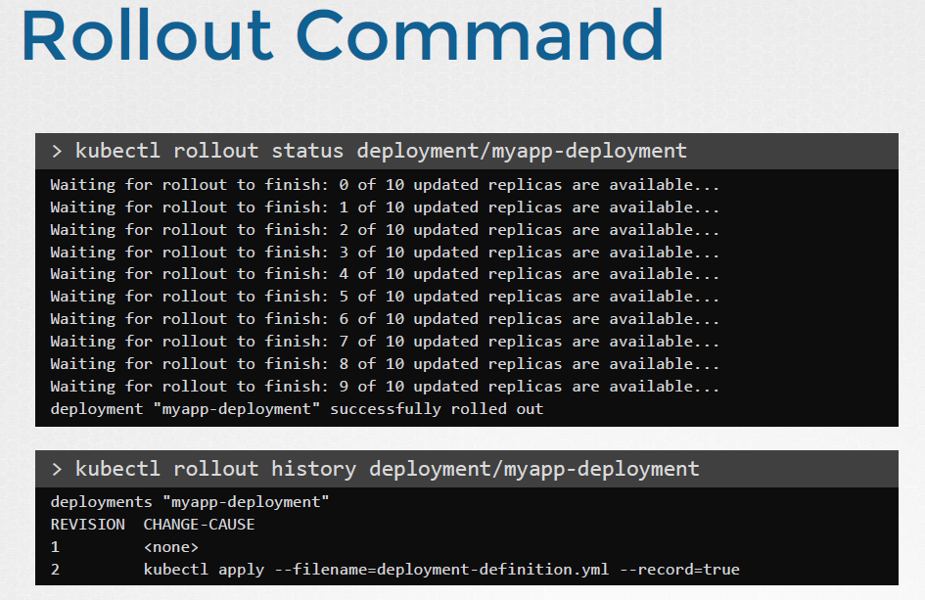

## **Deployment StrateGy**

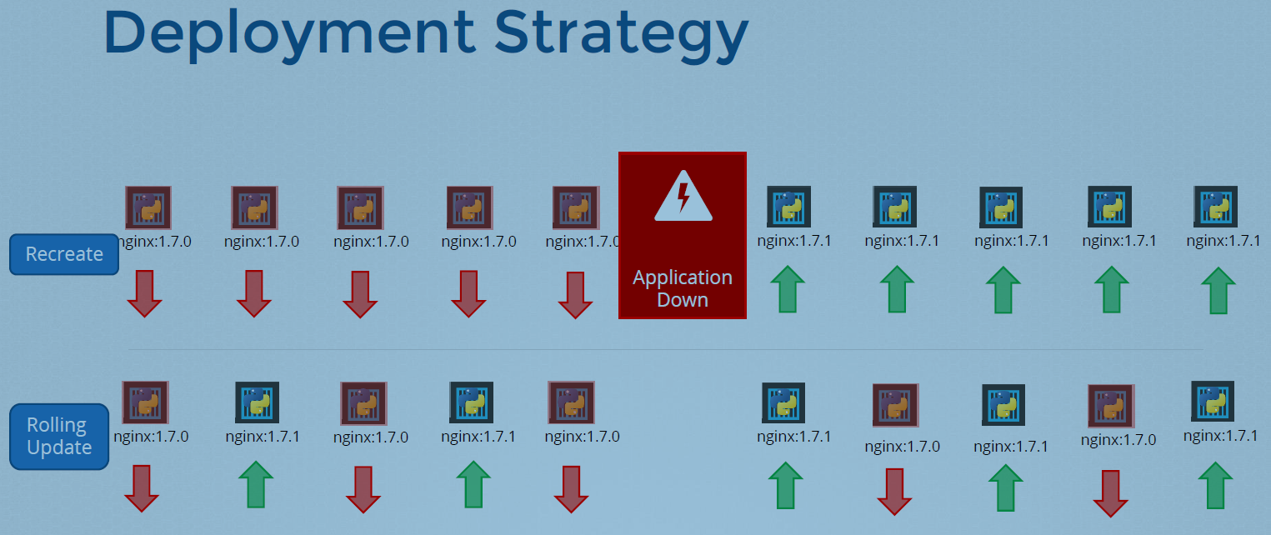

There are 2 types of Deployment strategies.

Say for example you have 4 replicas of your web application insatcne deployed.

**Recreate Strategy**

One way to updagrade these to a newer version is to destroy all of these and then create newer versions of application instances. **You will have Complete Application DownTime.**

**Rolling update Strategy [Default]**

We take older version and bring up a newer version one by one. This way the Application will never go down and upgrade is seamless.

## **How Exactly do you update your Deployment ??**

When I say update , It could be different thigs, such as updating your application version by updating the version of Docker Containes used, updating their labels or updating the number of replicas etc..

Once We made necesaay changes in the manifest file, we can use **$ kubectl apply command**

A new roll out is triggered and a new version after deployment is created.

Another way of doing is **$ kubectl set image deployment/myapp-deployment nginx=nginx:1.9.1**

But doing this way will result in the deployment but not in the definition file.

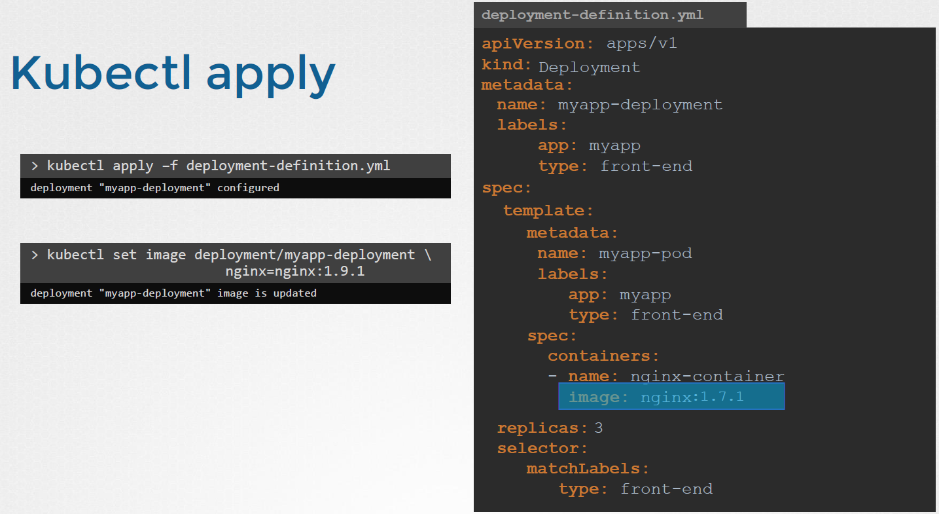

## **Upgrades & Rollback**

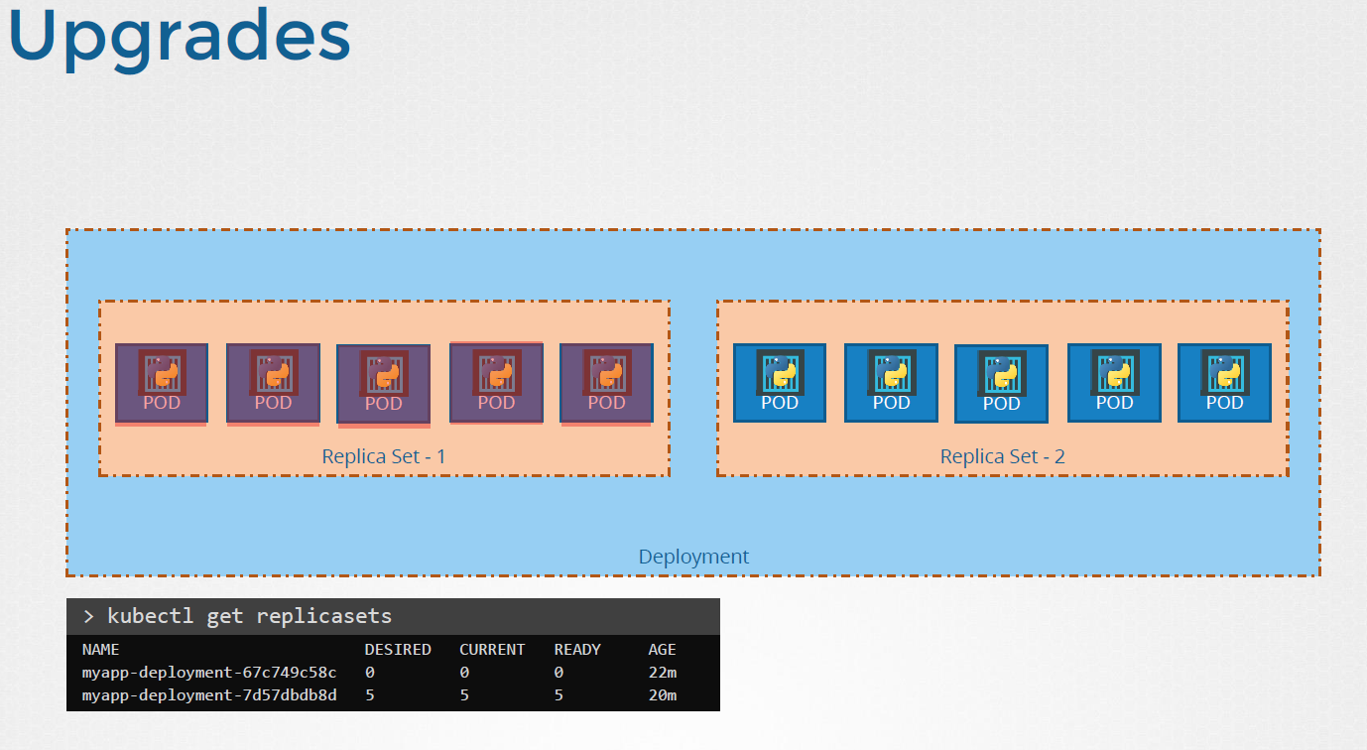

When new deployment is created say to deploy 5 replicas , It first creates replica set automcatcally, which in turn creates the number of parts required to meet the number of replicas.

When you upgrade your Application, Deployment object creates new Replica set and starts deploying the container there, At the same time taking down the pod in the old replica set following a rolling update strategry.

**RollBack**

Say or instance Once you upgade your application, you realize something is not right . so you would like to roll back your update.

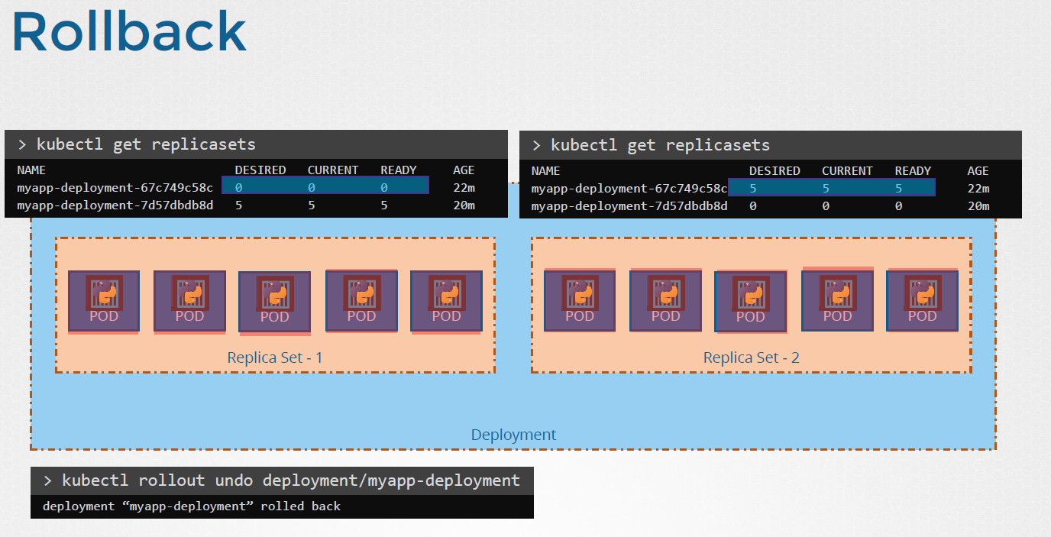

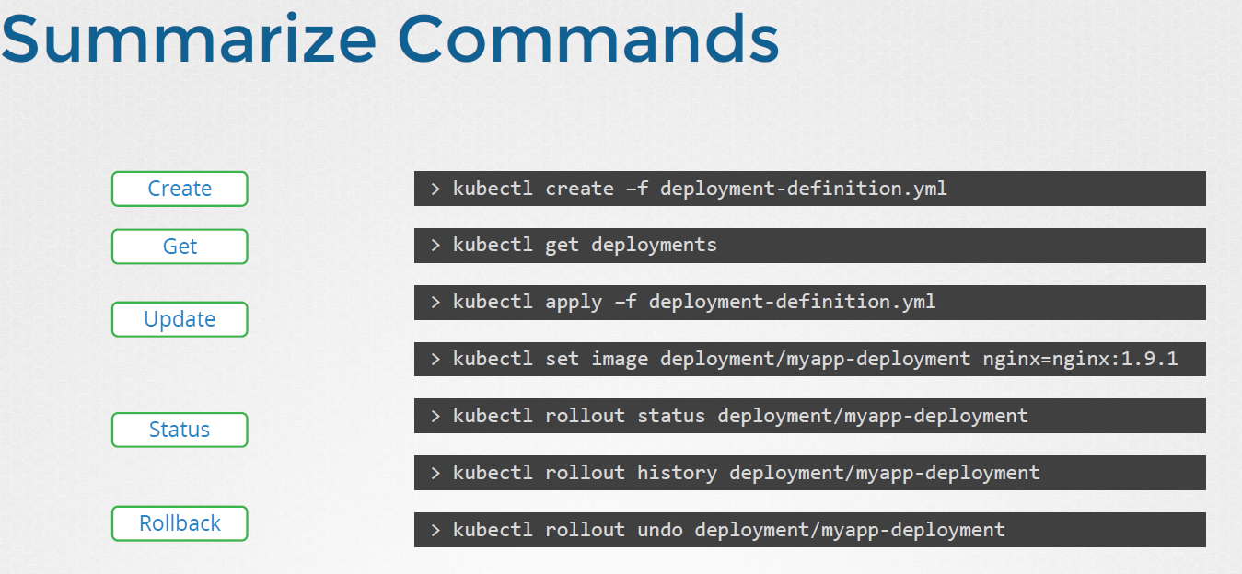

## **Commands && Arguments**

In Docker

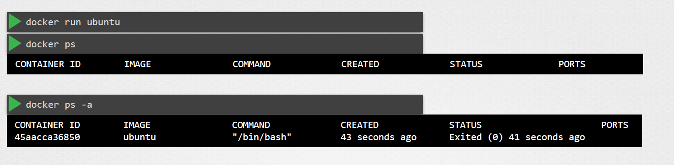

Container in exited state why ?

Unlike virtual machines Containers are not meant to host an operating system, Containers are meant to run a specific task or process such ass to host an instances of a web server or application server or simple carry out some kind of computation or analysis. Once the task is complete the container exists. Container only lives as long as the process inside it is alive.

If the webservice inside the container is stopped or crashed then the container exists.

**Default command instruction in image decides the fate**.

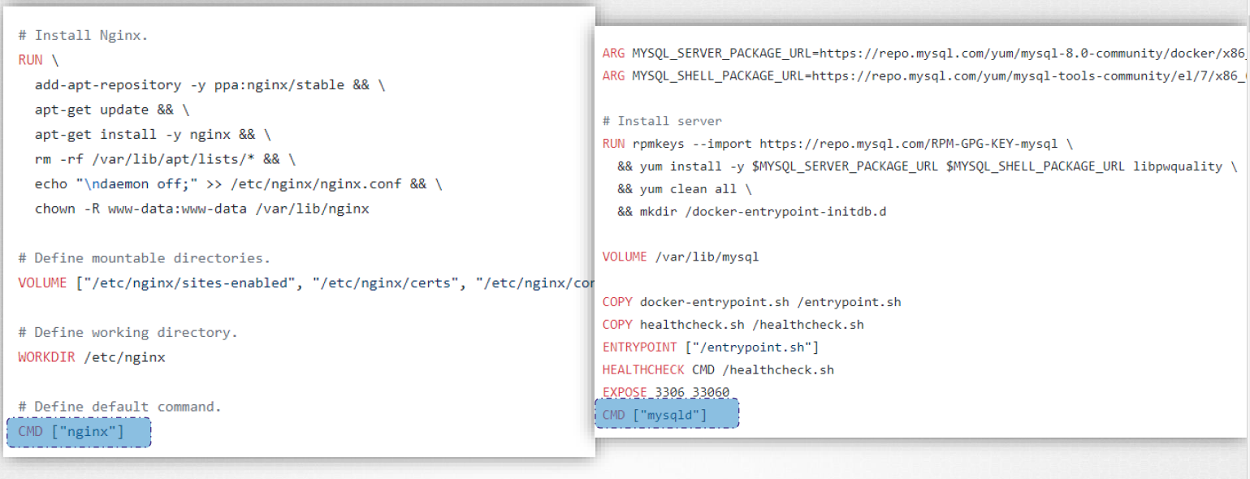

If it set as CMD [“bash”]

Then Now bash is not really a process like web server or DB server. It is a shell that listens the input from a terminal , if it cannot find a terminal it exits. When we ran the Ubuntu Container earlier Docker created a container from the Ubuntu image && launched the BASH program . By default Docker does not attach a terminal to a container when it is run and so the BASH program does not find the terminal and so it exits.

**So How do you specify Different commands to start the container ??**

One option is to append the a command to the Docker Run command and that way it overrides the default command specified in the image. [Temporary]

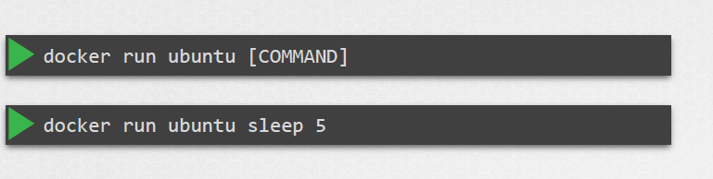

This way when the container starts it runs the sleep program waits for 5 sec and then exits.

**How do you make it permanently ??**

Say you want the image to always run the sleep command when it starts. Alter the Docker image having default command.

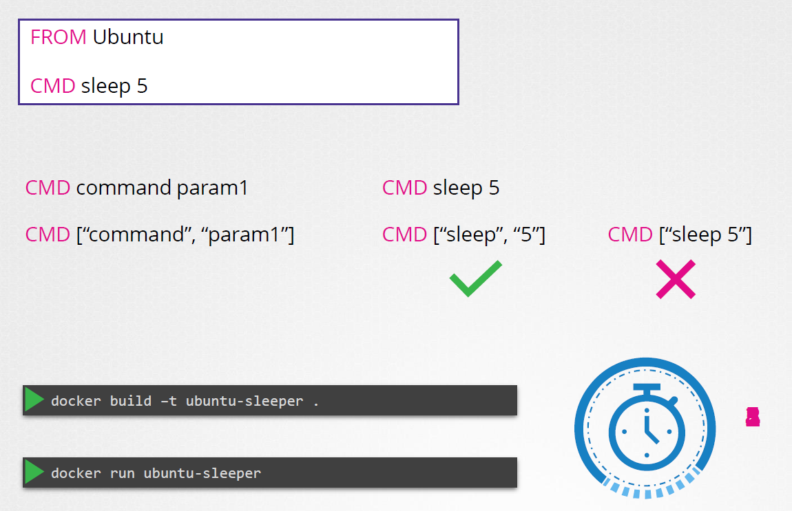

**As now it sleeps for 5 sec. What if you want to change this ??**

Sleep 10 overrides the CMD

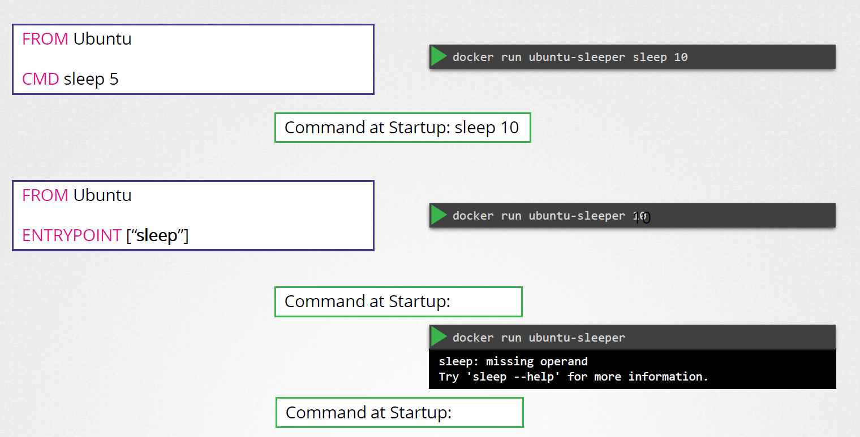

You can use the EntryPoint option. Thhe entry point instruction is like the command intruction , you can specify the program that will be run when the contianer starts and whatever you specify on the command line will get appended.

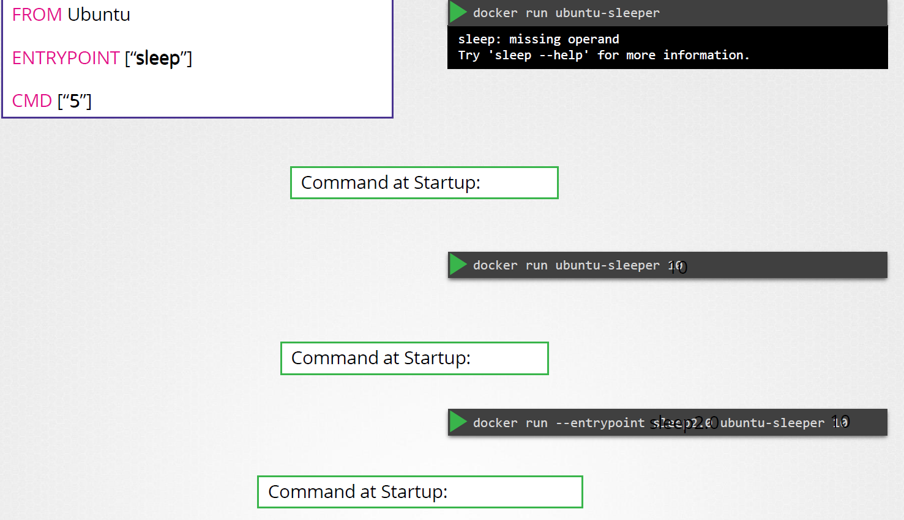

**Command && Arguments in K8s**

$ docker run –name ubuntu-sleeper ubuntu-sleeper #It sleeps for 5 secs

$ docker run –name ubuntu-sleeper ubuntu-sleeper 10 # sleeps for 10

**Now we will create a pod using this image . When this POD is created, it creates a container from the specified image && container sleeps for 5 sec default before exiting.**

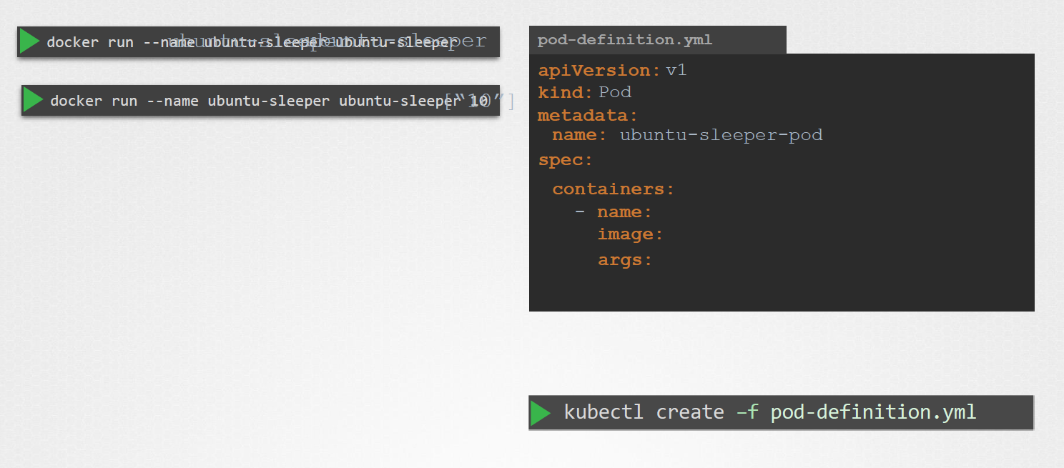

**Now if need the container to sleep for 10 sec as in the second command , how do you specify the additional ARG in pod definition file.**

**Anything that is appended to the docker run command will go into the “args” property.**

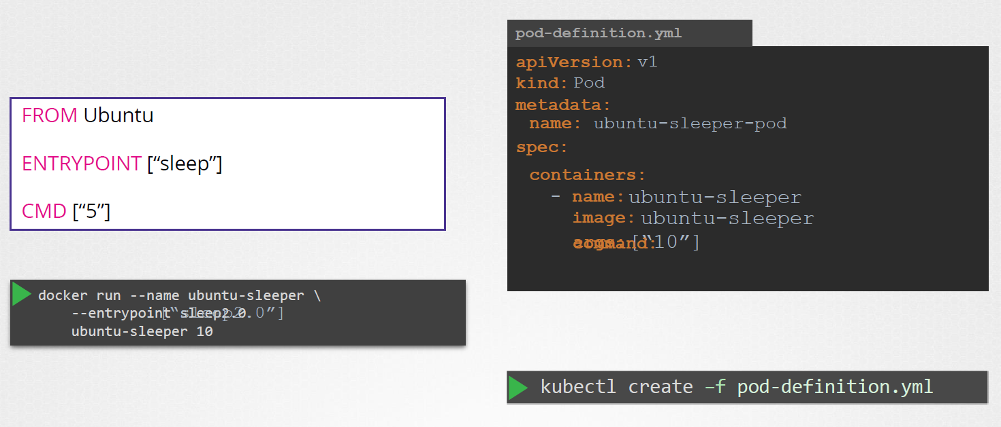

The Dockerfile has Entrypoint as well as CMD instruction specified. The Entrypoint is the command that is ru at the startup, and the CMD is the default parameter passed to the command. With args option in the pod def file , we override the CMD instruction in the Dockerfile**. But what if you need to override the entrypoint ?? say from sleep to sleep 2.0.**

**In the docker world we would run the docker run command with the entry point option set to the new command. The corresponding entry in the pod definition file would be using a command field**

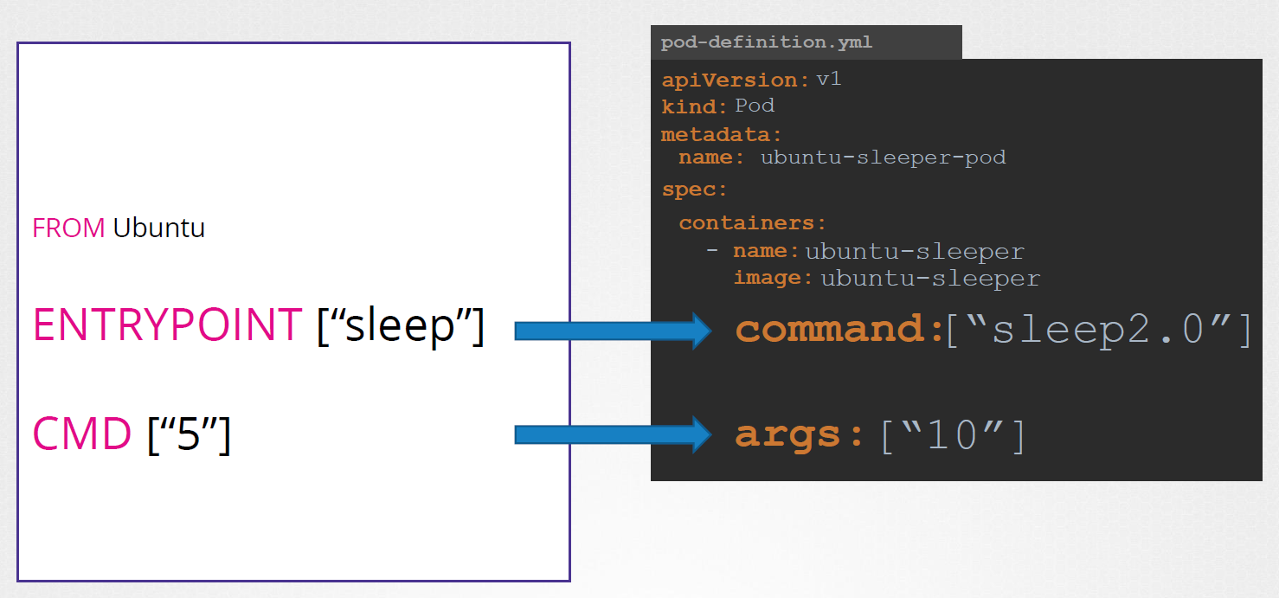

**Command field overrides Entrypoint**

**Args field overrides CMD**

## **ENV variables in Pod Def File**

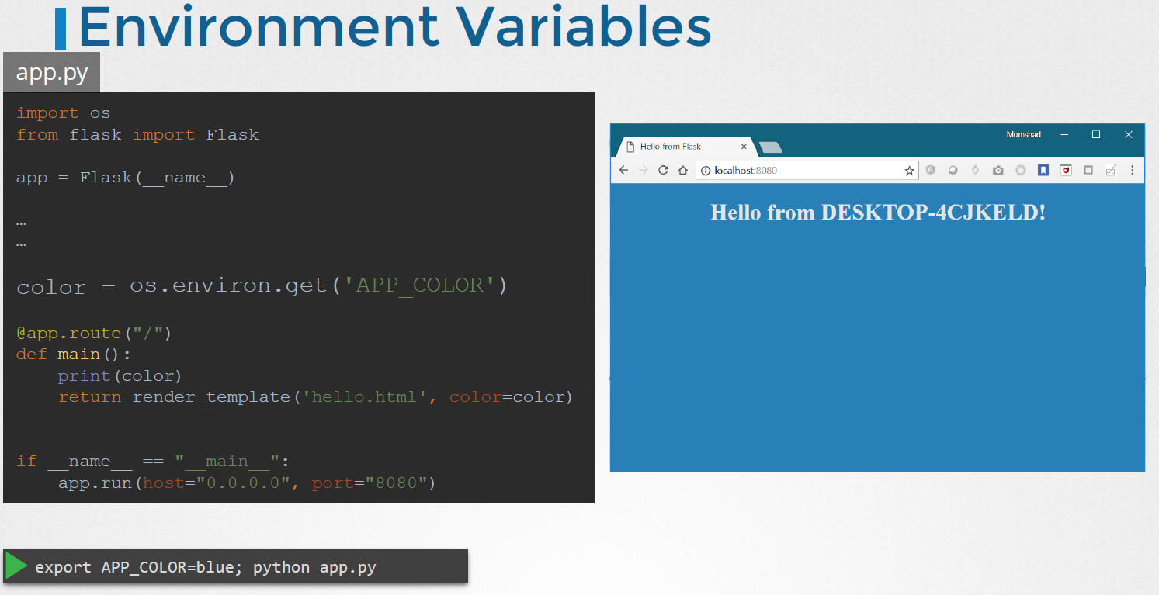

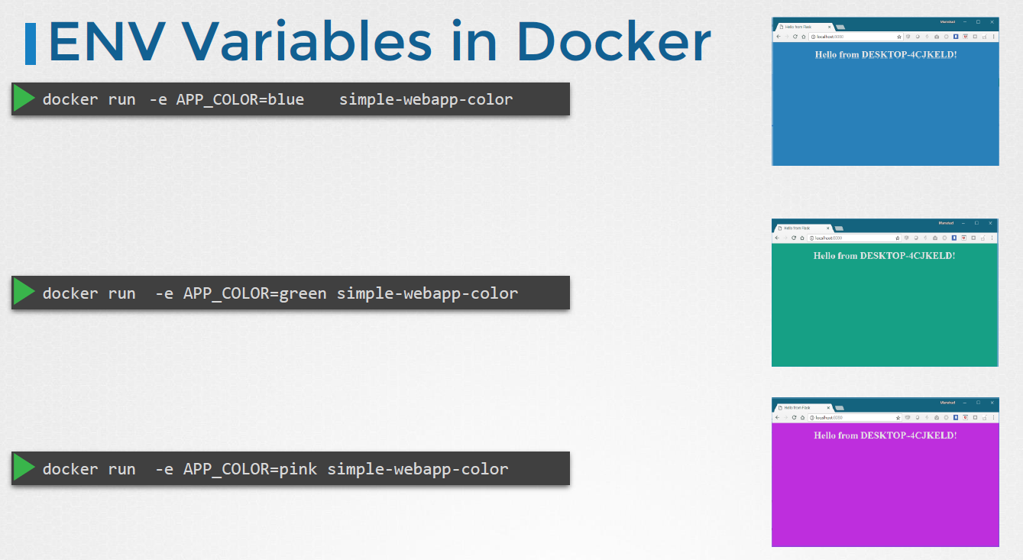

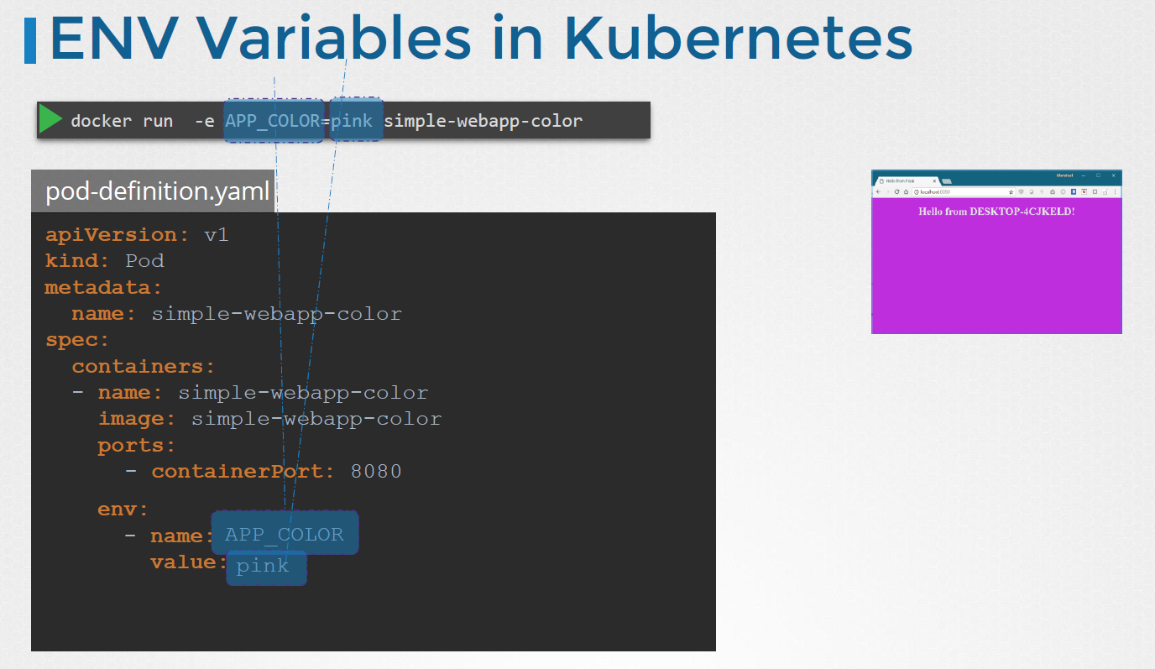

**Way of declaring the env in K8s**

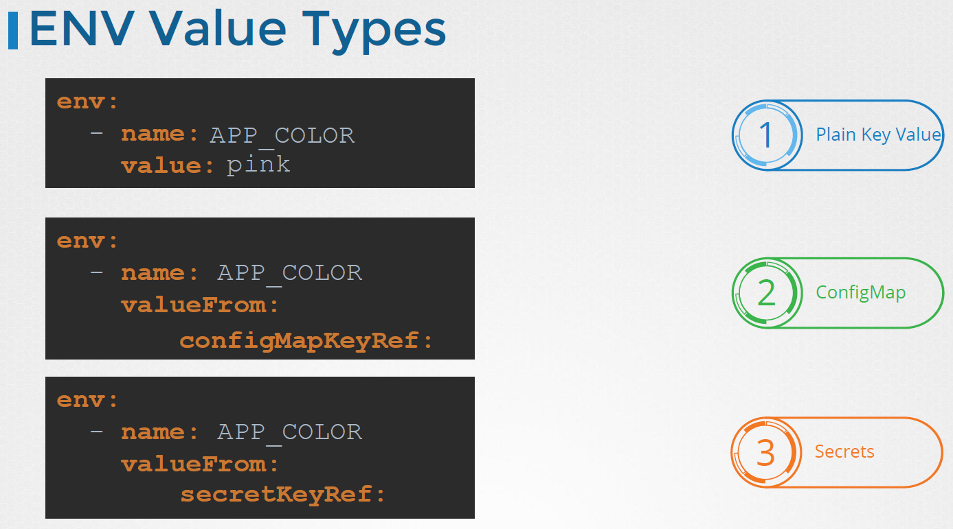

## **ConfigMaps in Application**

When we have a lot POD definition files it will become difficult to manage the environment data stored within the query files. We can take this information out of the pod definition file and manage it centrally using **ConfigMap**  
  
  
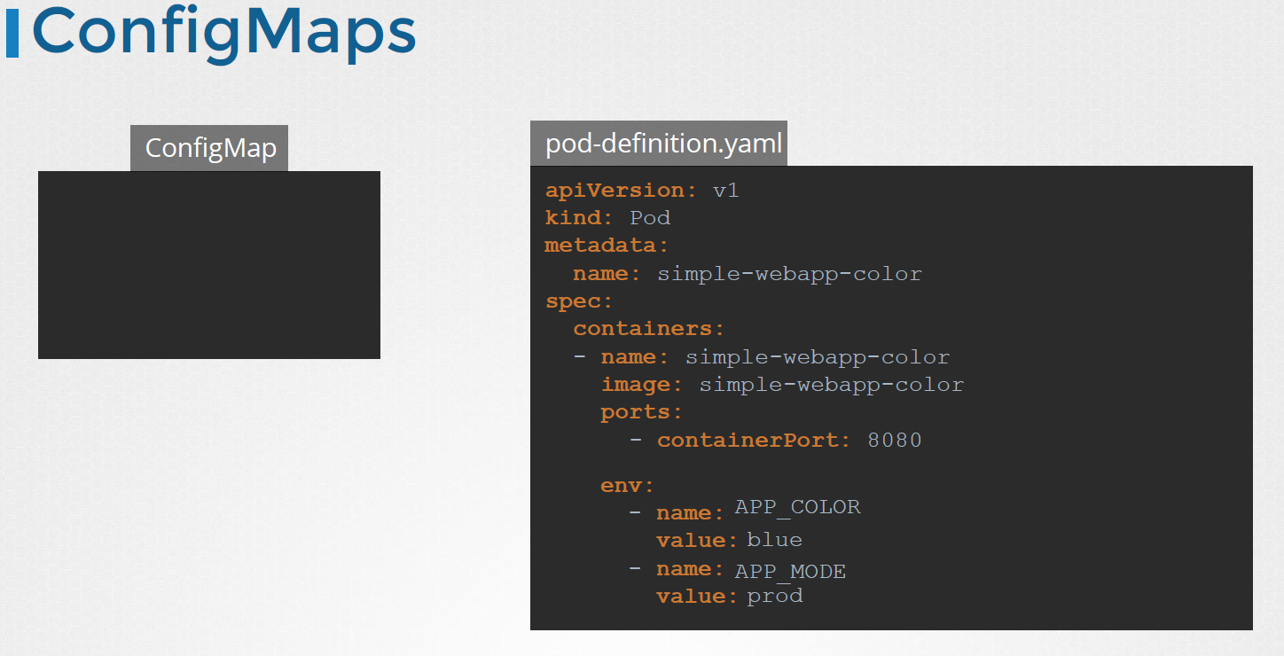

**ConfigMaps are used to pass the configuration data in the form of key value pairs in Kubernetes. When a pod is created , Inject the config map into the pod, so that the key value pairs are available as environment variables for the application hosted inside the container in the pod.**

**There are 2 phases involved in config maps.**

**1st Create the config map**

**2nd Inject them into the POD**

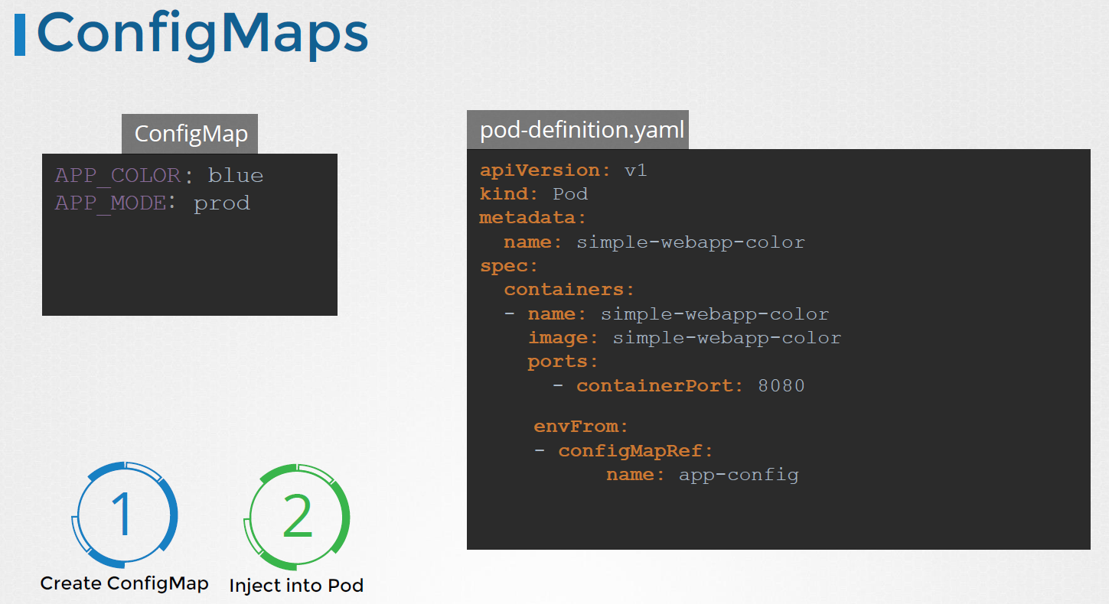

**Creating ConfigMaps**

There are two ways of creating a configMap .

Imperative way :: Without using a ConfigMap definition file

Declarative way :: Using ConfigMap Definition File

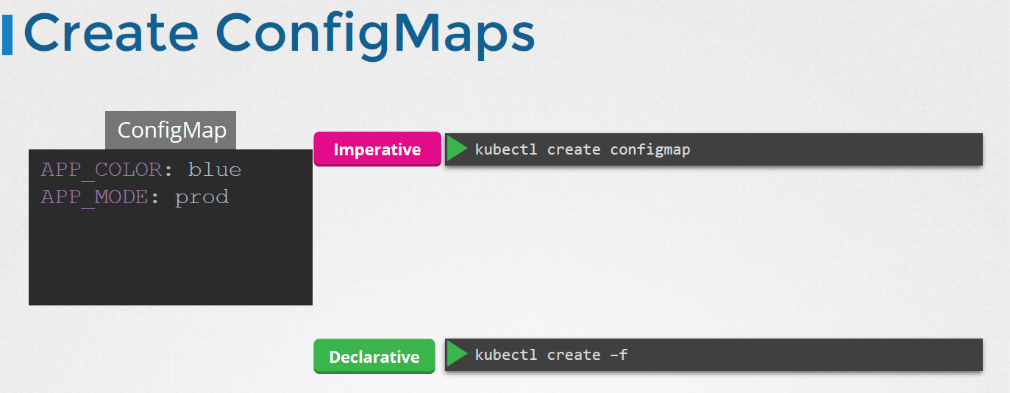

**Imperative Way**

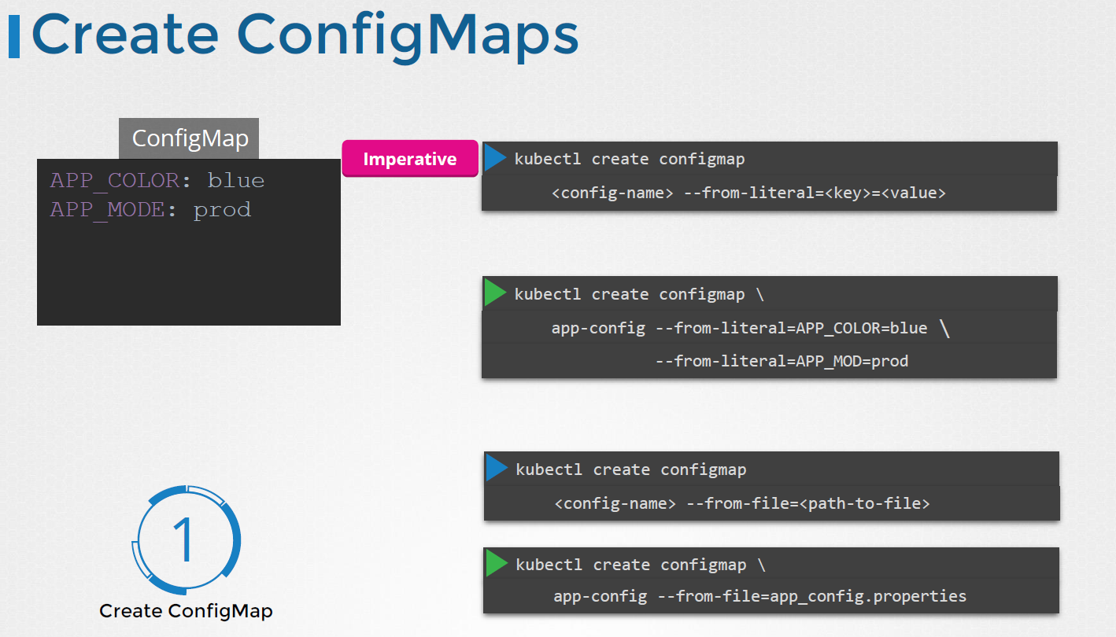

From-literal option used to specify the key value pairs in the command itself.

Another way to input the configuration data is through a file. Use the from-file option to specify a path to the file that contains the required data. The data from this is read and stored under the name of the file.

**Declarative Approach**

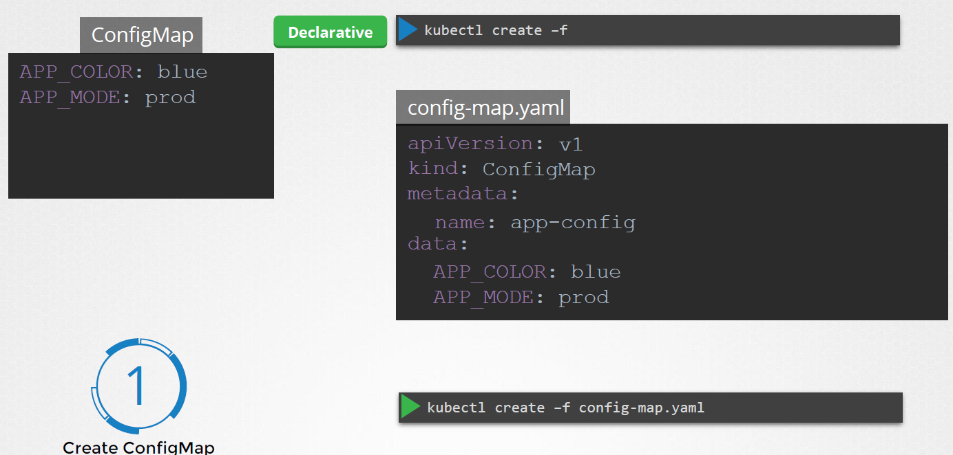

**You can create Multiple configMaps**

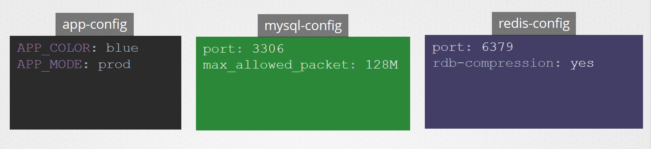

**View Config Maps**

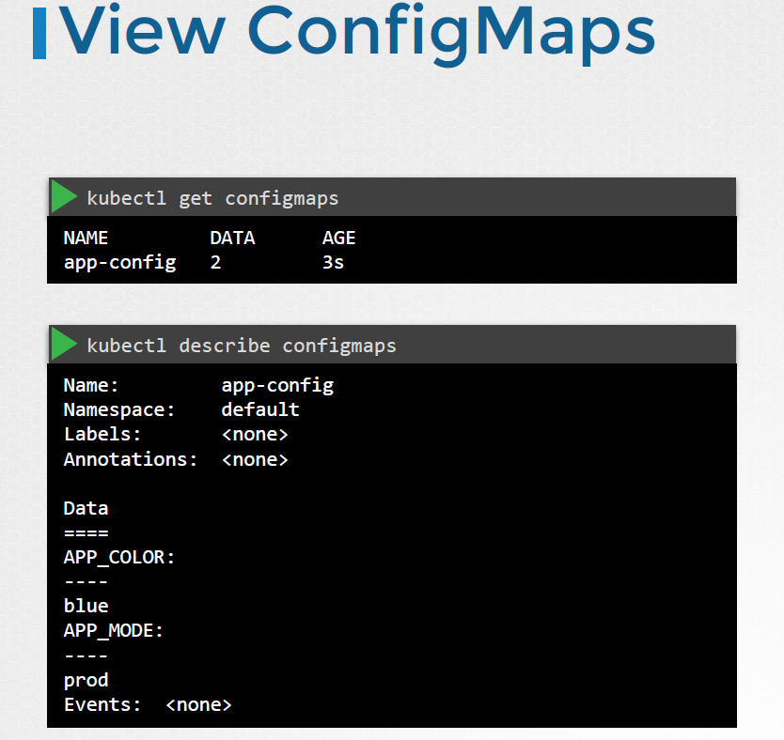

**Step 2 :: Assocaiting the configMap to the POD**

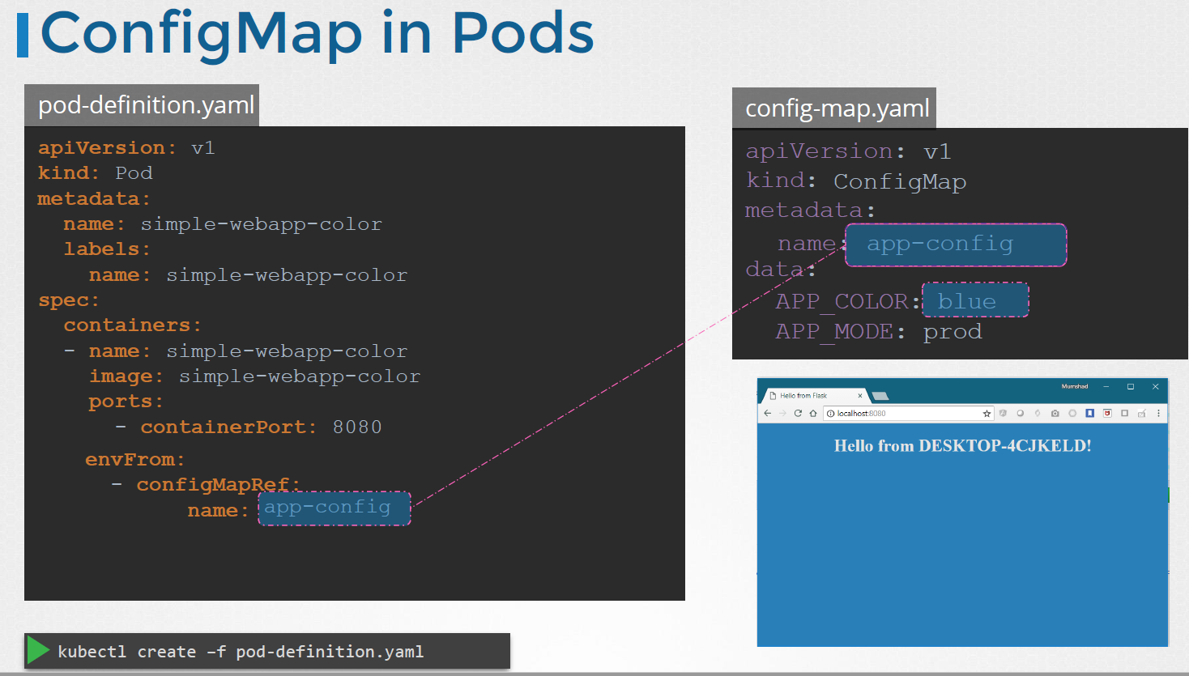

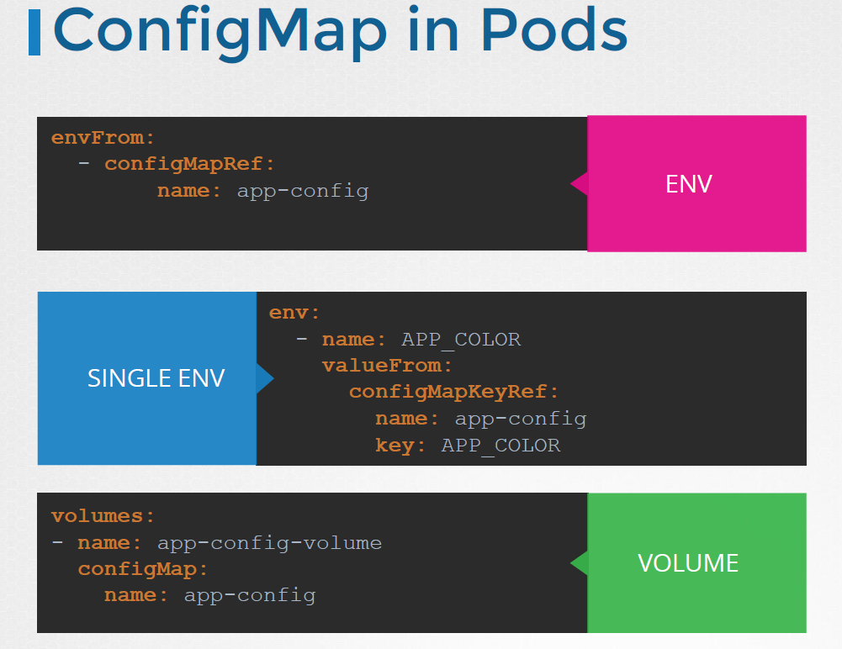

## **Configure Secrets in Applications**

Config map is not the best way when comes to secrets  
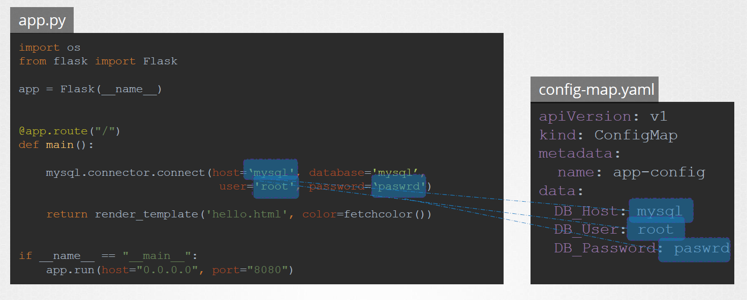

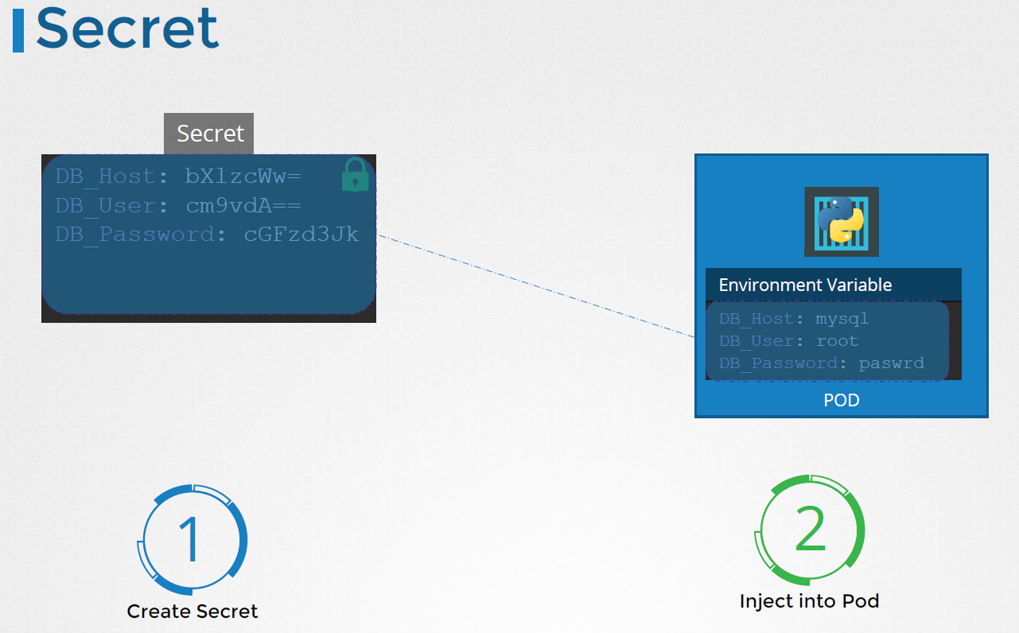

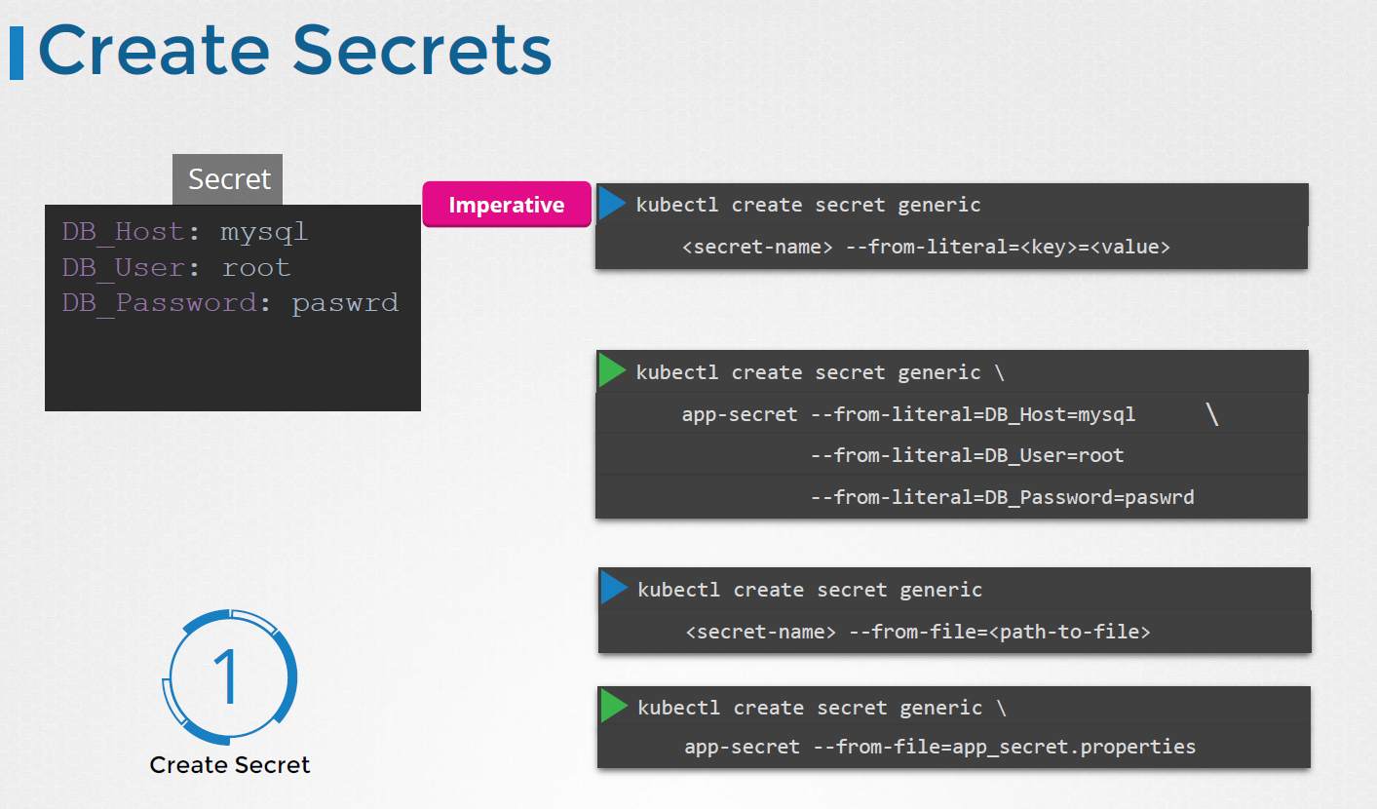

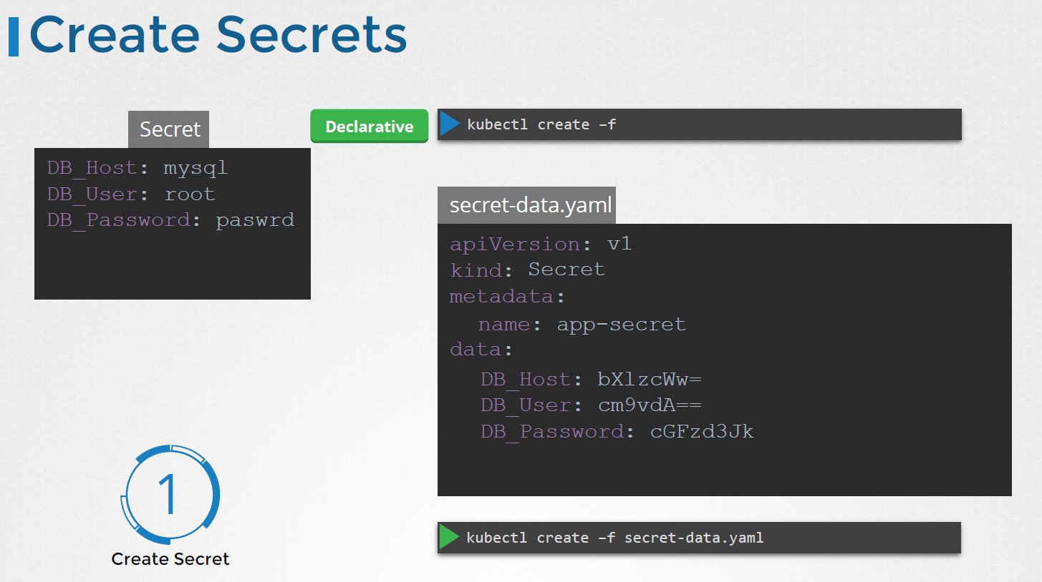

Here in configuration file you need to encode the variable and then use that instead of plain text.

